**DBMS LAB OUTPUTS**

**Name:Omesh Balamurugan Roll no.: 230701222**

**Ex.No.:1**

**Creation of database and DLM operation**

1. Create table MY_EMPLOYEE (ID number(4), Last_name varchar(25), First_name varchar(25), Userid varchar(25), Salary number(9,2);
2. Begin

Insert into MY_EMPLOYEE values(1,’Patel’,’Ralph’,’rpatel’,895);

Insert into My_EMPLOYEE values(2,’Dancs’,’Betty’,’bdancs’,860);

End;

1. Select * from MY_EMPLOYEE;

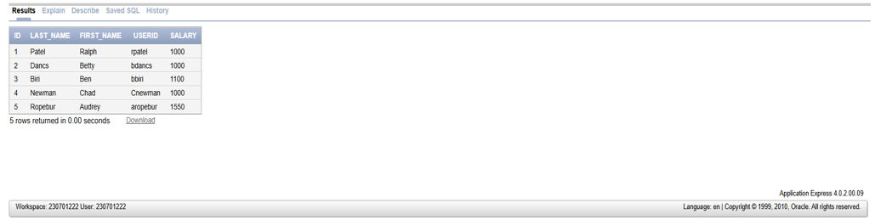

1. Update MY_EMPLOYEE set user_id=concat(substr(First_name,1,1),substr(Last_name1,7));

Output: 5 row(s) updated.

1. Delete from MY_EMPLOYEE where Last_name=’Dancs’;

Output: 1 row(s) deleted.

1. Delete from MY_EMPLOYEE where ID = 4;

Output: 1 row(s) deleted.

1. COMMIT;
2. Update MY_EMPLOYEE set Last_name = ‘Drexler’ where ID = 3;

Output: 1 row(s) updated.

1. Update MY_EMPLOYEE set salary = 1000 where salary < 900;

Output: 1 row(s) updated.